PRACTICAL 5
Name : Ranudi Gayathmie Kariyapperuma
Index : 29897
Batch No : 23.1
Degree Program Name : Technology Management

Section A

(Q1) - While Loop

int main()
{
int a=0;
while(a<=100)
{
printf("%d ",a);
a++;
}
return 0;
}

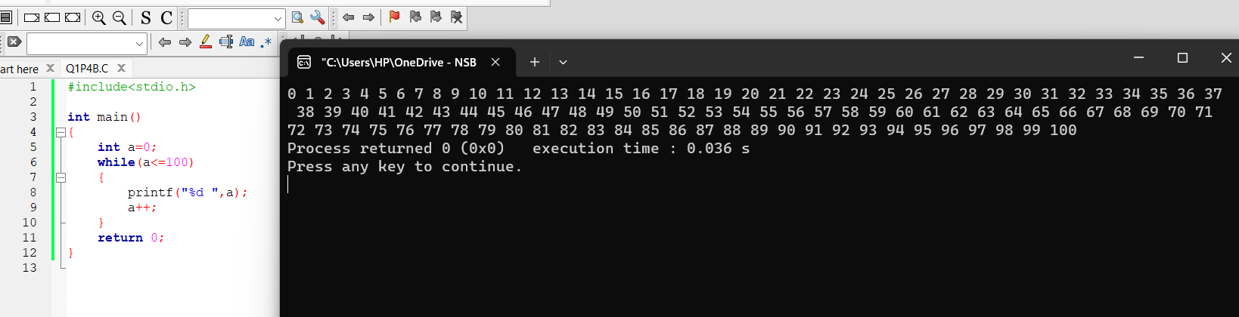

- Do while

#include<stdio.h>

int main()
{
int a=0;
do
{
printf("%d ",a);
a++;
}

while(a<=100);

return 0;
}

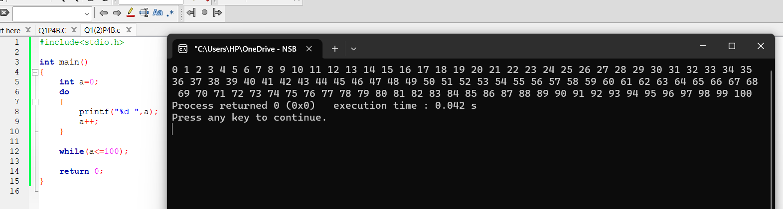

- For Loop

#include<stdio.h>

int main()
{
int a;
for(a=0;a<=100;a++)
{
printf("%d ",a);

}
return 0;
}

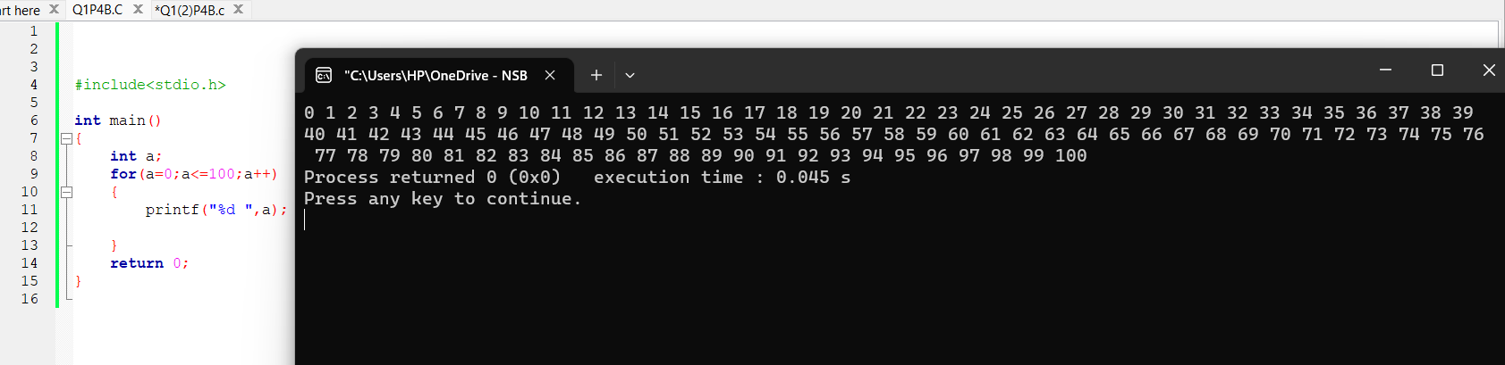

Q2) #include <stdio.h>
int main()
{
int marks[10],total=0;
float avg;

for(int i=0;i<10;i++)
{
printf("Enter %d mark : ",i+1);
scanf("%d",&marks[i]);
total+= marks[i];
}
printf("Total:%d \n",total);
printf("Average:%.2f \n",(float)total/10);

avg=(float)total/10;

if(avg>50)
{
printf("Pass\n");
}
else
{
printf("Fail\n");
}
return 0;
}

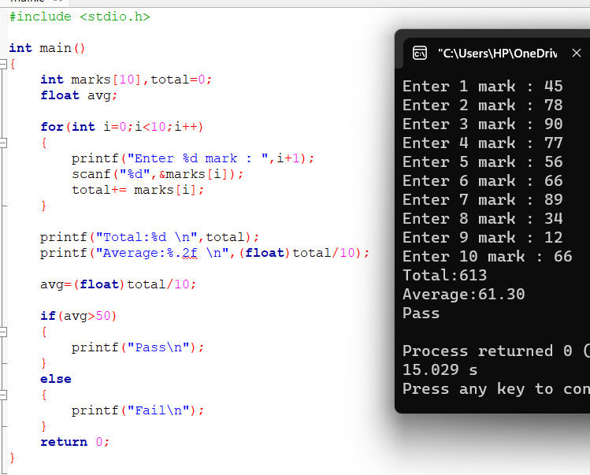

Q3) #include <stdio.h>
int main()
{
int number,i;
int factorial=1;

printf("Enter a number: ");
scanf("%d",&number);
if(number<0)
{
printf("Not calculatable\n");
}
else if(number==0)
{
printf("Factorial of %d is %d \n",number,1);
}
else
{
for(i=1;i<=number;i++)
{
factorial *= i;
}
printf("Factorial of %d is %d \n",number,factorial);
}
return 0;
}
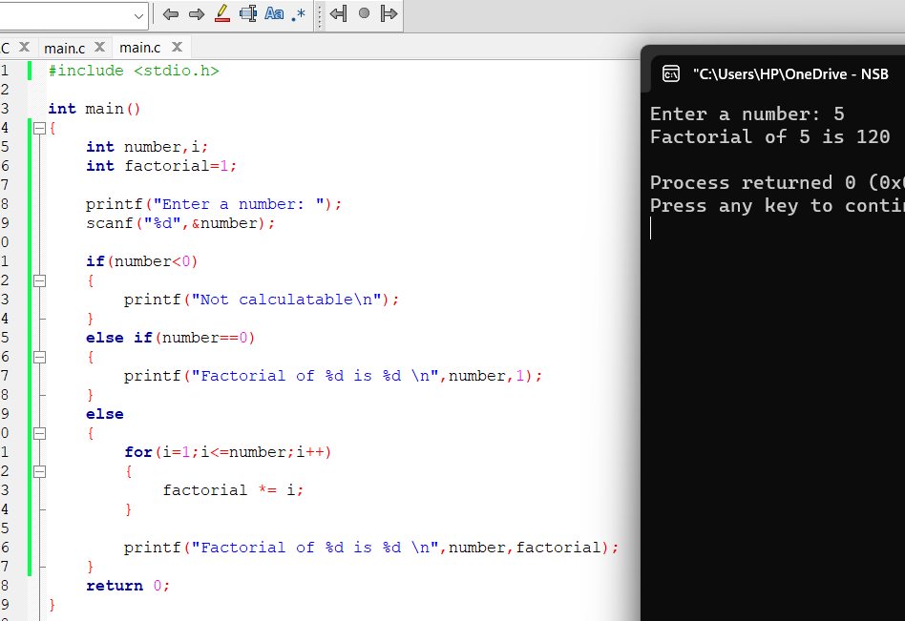
Q4) #include <stdio.h>
int main()
{
int n,sum=0,a;
printf("Enter a Number: ");
scanf("%d",&n);

while(n>0)
{
a=n%10;
sum=sum+a;
n=n/10;
}
printf("The sum of digits : %d\n",sum);
}

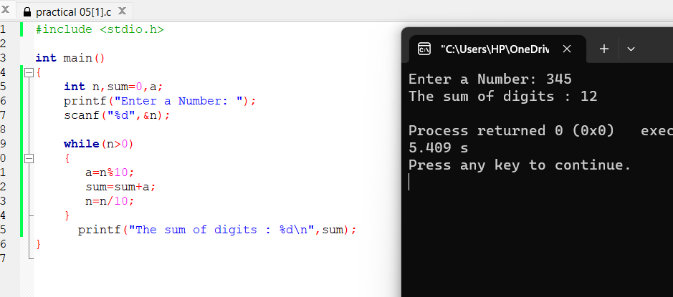

Q5)

#include <stdio.h>
int main()
{
int n,reverse;
printf("Enter number: ");
scanf("%d",&n);
do
{
reverse=n%10;
printf("%d",reverse);
n=n/10;
}

while(n>0);
return 0;
}

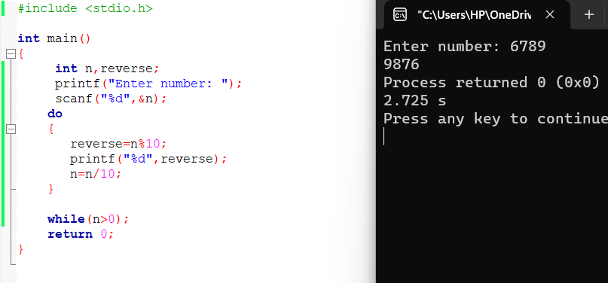

Q6) #include <stdio.h>
int main()
{
int f,q,c=1;
printf("Enter a value: ");
scanf("%d",&f);
printf("Now enter the power of it: ");
scanf("%d",&q);

if(q==0)
{
c=1;
}
else
{
for(q;q>0;q--)
{
c=c*f;
}
}
printf("The answer is %d\n",c);
return 0;
}

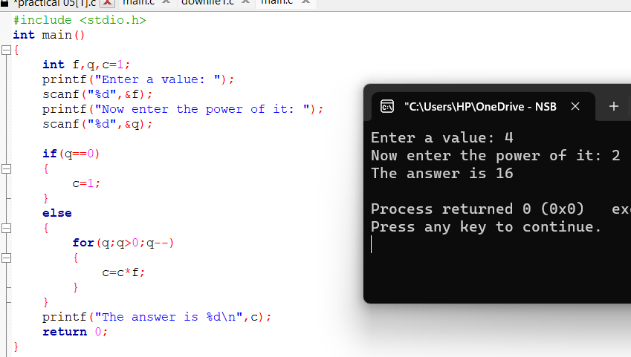
Q7) #include <stdio.h>
int main()
{
int n1=0,n2=1,n3,count,num;

printf("Enter the first 10 numbers of fibonanci \n");
scanf("%d",&num);

printf("\n%d\n%d\n",n1,n2);

for(count-3;count<=num;count++)
{
n3=n1+n2;
printf("%d\n",n3);

n1 = n2;
n2 = n3;
}
return 0;
}

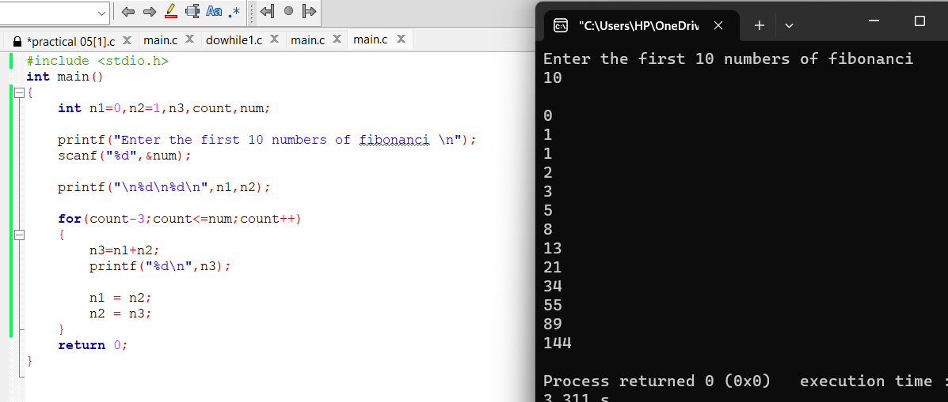

Q8)

#include <stdio.h>
int main()
{
int n,arms=0,r,c;
printf("Enter a number: ");
scanf("%d",&n);
c=n;
while(n>0)
{
r=n%10;
arms=(r*r*r)+arms;
n=n/10;
}
if(c==arms)
printf("Armstrong Number\n");
else
printf("Not an Armstrong Number\n");

return 0;
}

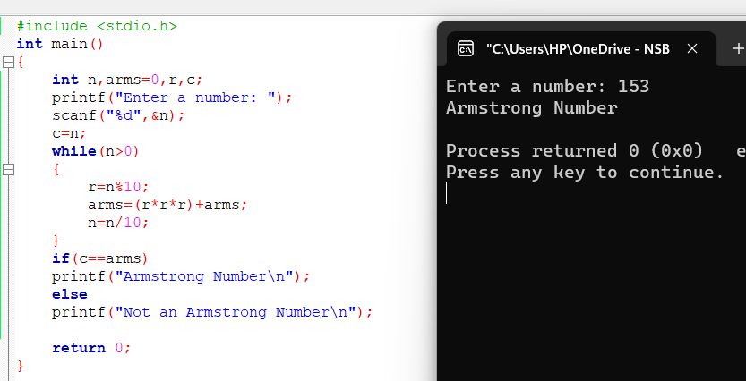
Q9)

#include <stdio.h>

int main()
{
int al;
printf("These are the ASCII values from A to Z.\n\n");
for(al=65;al<=90;al++)
{
printf("%d ",al);
}
return 0;
}

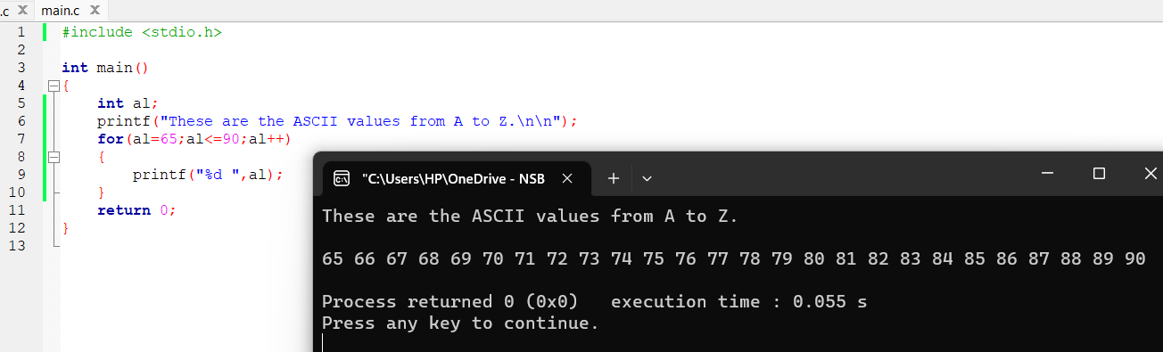

Q10)

#include <stdio.h>
int main()
{
int a,r;
for(a=1;a<=5;a++)
{
for(r=1;r<=a;r++)
{
printf("*");
}
printf("\n");
}
return 0;
}

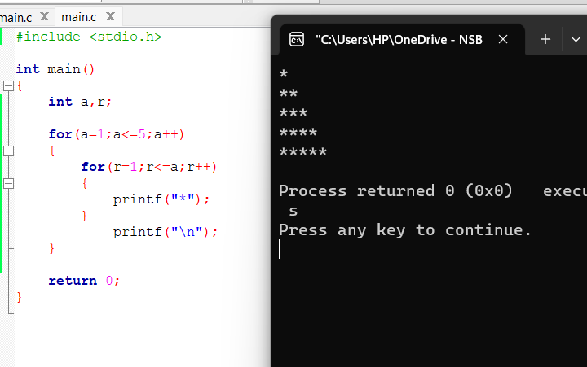

Q11)

#include <stdio.h>
int main()
{
int n,i,count=0;
printf("Enter a number: ");
scanf("%d",&n);
for(i=1;i<=n;i++)
{
if(n%i==0)
{
count++;
}
}
if(count==2)
printf("%d is a prime Number\n",n);
else
printf("%d is Not a prime Number\n",n);
return 0;
}

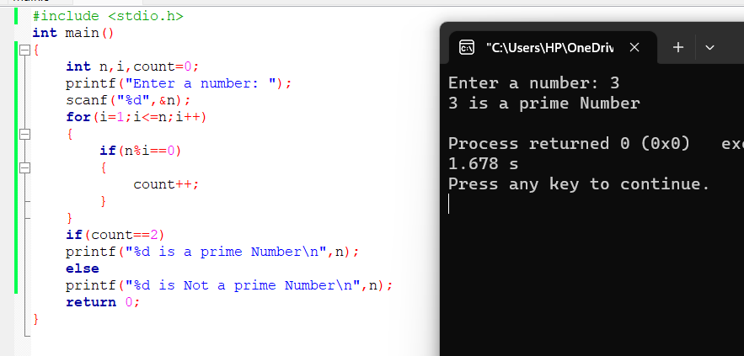

Q12)

#include <stdio.h>
int main()
{
int no,counter;
printf("Enter a number to find factors: ");
scanf("%d",&no);
printf("Factors of %d are: \n",no);
for(counter=1;counter<=no;counter++)
{
if (no%counter==0)
printf("%d\n",counter);

}

return 0;
}

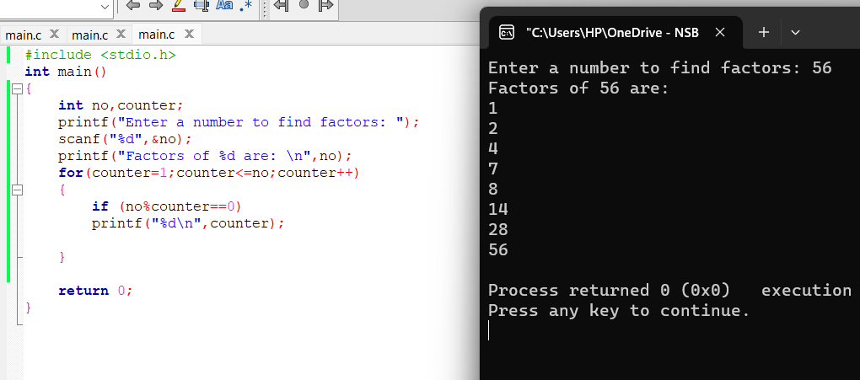

Q12)
#include <stdio.h>
int main()
{
int g,total=0,r;
printf("Enter numbers : ");
scanf("%d",&g);
if(g==-1)
{
printf("\nThe total is %d",g);
}
else
{
for(r=0;r==0;)
{
total+=g;
scanf("%d",&g);
if(g==-1)
{
r=1;
}
}
printf("\nThe total is %d\n",total);
}
return 0;
}

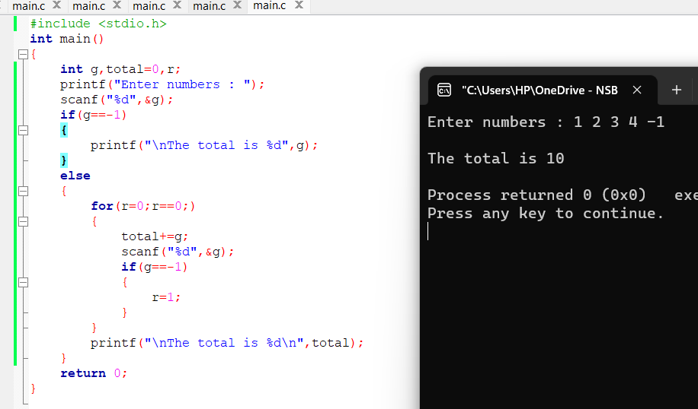

Q13)

#include <stdio.h>
int main()
{
int i,arr[10];
for(i=0;i<10;++i)
{
printf("Enter a value to the element %d : ",i+1);
scanf("%d",&arr[i]);
}
for(i=0;i<10;i++)
printf("%d ",arr[i]);

return 0;
}

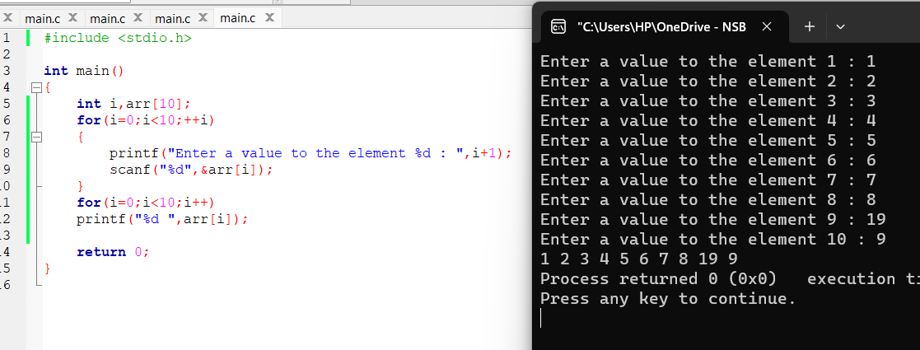

Q14)

#include <stdio.h>
int main()
{
int i,arr[10],evenc=0;
for(i=0;i<10;i++)
{
printf("Enter %d value: ",i+1);
scanf("%d",&arr[i]);
}
for(i=0;i<10;i++)
{
if(arr[i]%2==0)
evenc++;
}
printf("\nCount of even numbers %d \n",evenc);
return 0;
}

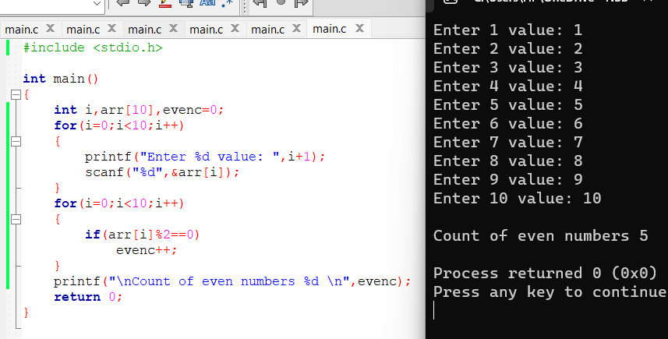

Section B

Q1)
#include <stdio.h>
int main()
{
{int no,counter=0,negative=0,positive=0,zero=0;

for(counter;counter<10;counter++)
{
printf("Enter number : ");
scanf("%d",&no);
if(no==0)
{
zero++;
}
else if(no<0)
{
negative++;
}
else
{
positive++;
}
}
printf("There are \n %d positive numbers \n %d negative number
\n %d Zeros",positive,negative,zero);
return 0;
}
}

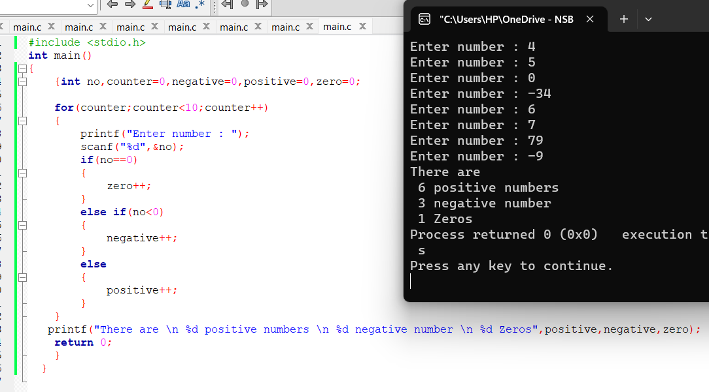

Q2)

#include <stdio.h>
int main()
{
int i,marks[10],max,min,total=0;
float avg;
printf("Enter the marks of 10 students\n\n");

max=marks;
min=marks;
for(i=0;i<10;i++)
{
printf("Enter marks for student %d: ",i+1);
scanf("%d",&marks[i]);
total+=marks[i];
if(i==0||marks[i]>max)
{
max=marks[i];
}

if(min>marks[i])
{
min=marks[i];
}
}
avg=(float)total/10;

printf("\nThe maximum number is %d\n",max);
printf("The minimum number is %d\n",min);
printf("The average is %2f\n",avg);
return 0;
}

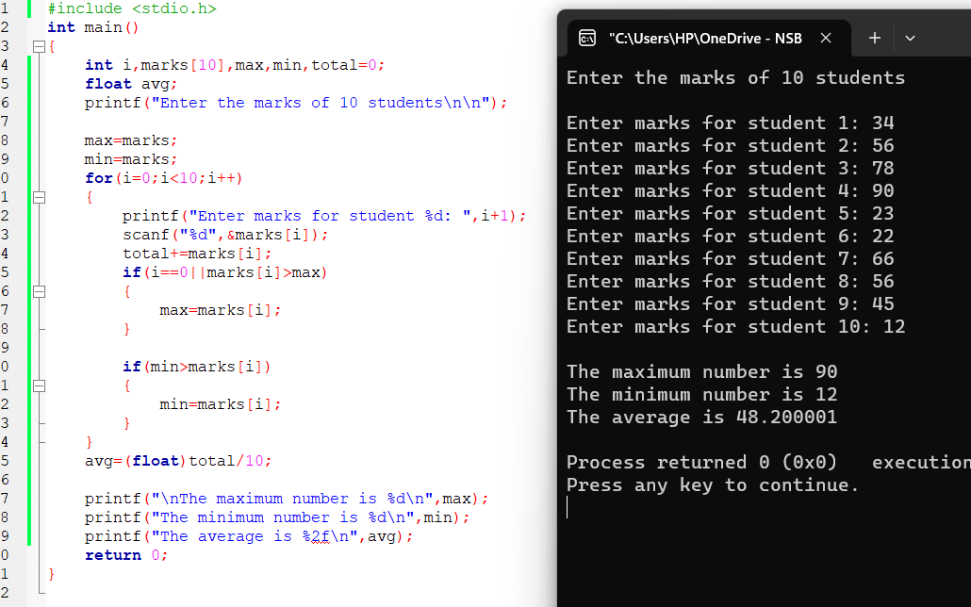

Q3)

#include <stdio.h>
int main()
{
int counter,no=0,total=0;
float prices[10],avg;
printf("Enter 10 items prices\n");
for(counter=0;counter<10;counter++)
{
printf("Enter price for item %d :",counter+1);
scanf("%f",&prices[counter]);
total+=prices[counter];
if(prices[counter]>200)
{
no++;
}
}
avg=(float)total/10;
printf("\nThe average value is %f\n",avg);
printf("The number of items which greater than 200 is %d\n",no);
return 0;
}

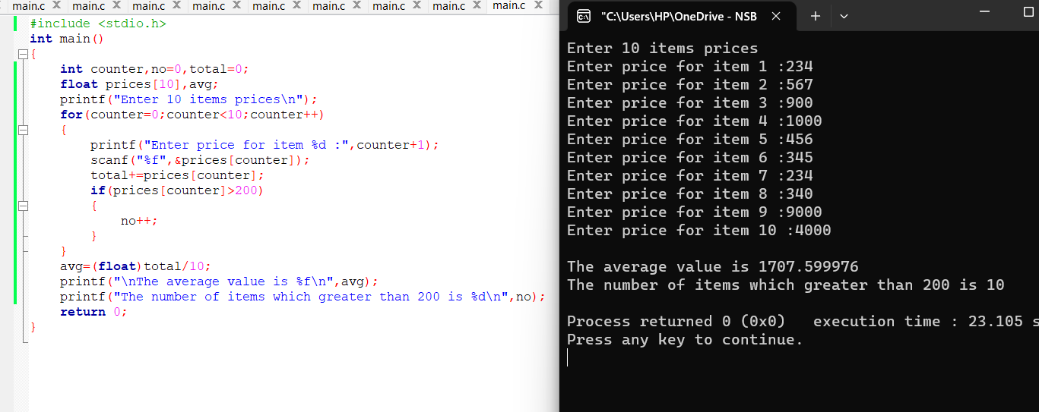
Q4)

#include <stdio.h>
int main()
{
int empno,counter=0;
float basicsalary;
printf("Enter the employee number and basicsalary(enter -999 to stop employee number) \n");

while(1)
{ printf("\nEmployee no: ");
scanf("%d",&empno);

if(empno==-999)
{
break;
}
printf("Basic Salary: ");
scanf("%f",&basicsalary);

if(basicsalary>=5000)
{
counter++;
}
}
printf("\nThe number of employees whose Basic Salary >=5000 is
%d\n",counter);
return 0;
}

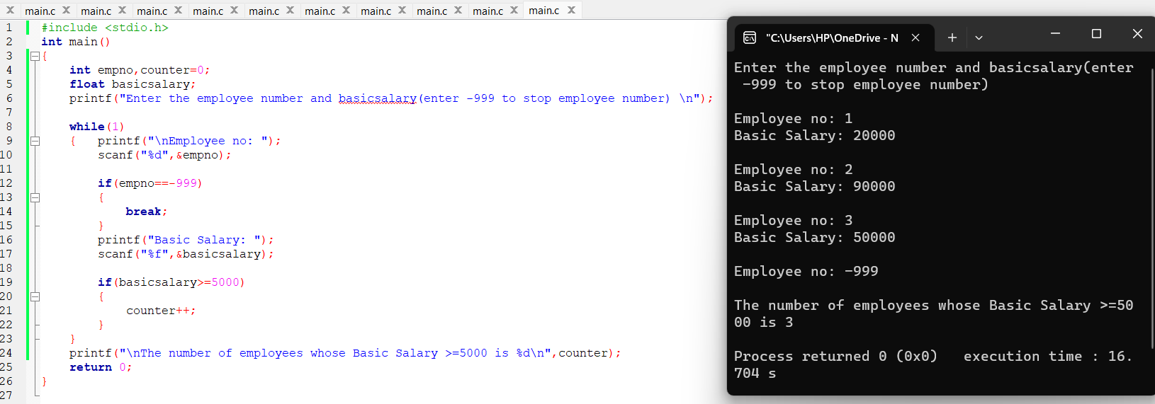

Q5) #include <stdio.h>
int main()
{
int empno,workhours,overtpayment,counter=0,totalemp=0;
printf("Enter your employee number hours worked(enter-999 to stop employee number)\n");

while(1)
{
printf("\nEnter Employee No: ");
scanf("%d",&empno);

if(empno==-999)
{
break;
}
printf("Enter Hours Work: ");
scanf("%d",&workhours);

totalemp++;

if(workhours<=40)
{
overtpayment=0;
}
else
{
overtpayment=workhours-40;
overtpayment=(overtpayment*150)+((40-workhours)*150);
}

if(overtpayment)
printf("Employee No: ",empno);
printf("overtimepayment: ",overtpayment);

if(overtpayment>=4000)
{
counter++;
}

float percentage=((float)counter/totalemp)*100;

printf("Percenntage of employees with overtime payment
exceeding Rs4000 : %2f ",percentage);
}
return 0;
}

